Lab Exercise - Configure Azure Alert, Action Group, and Trigger an Azure Functions Function

Objective
In this lab, you will:
- Create an Azure Function App
- Create an HTTP Trigger Azure Function
- Create an Action Group
- Configure Azure Monitor Alert
- Trigger the alert
- Automatically invoke the Azure Function

Prerequisites
- Azure Subscription
- Azure Cloud Shell
- Bash Shell enabled
Open:
Azure Portal
Launch Cloud Shell → Bash.

Architecture
Azure Monitor Alert
|
Action Group
|
Azure Function App
|
HTTP Trigger Function Executes

Step 1: Create Variables
RESOURCE_GROUP=rg-alert-lab
LOCATION=eastus
STORAGE_NAME=alertstorage$RANDOM
FUNCTION_APP=alertfuncapp$RANDOM
ACTION_GROUP=alertActionGroup

Step 2: Create Resource Group
az group create \
--name $RESOURCE_GROUP \
--location $LOCATION

Step 3: Create Storage Account
az storage account create \
--name $STORAGE_NAME \
--resource-group $RESOURCE_GROUP \
--location $LOCATION \
--sku Standard_LRS

Step 4: Create Function App
az functionapp create \
--resource-group $RESOURCE_GROUP \
--consumption-plan-location $LOCATION \
--runtime python \
--runtime-version 3.11 \
--functions-version 4 \
--name $FUNCTION_APP \
--storage-account $STORAGE_NAME \
--os-type Linux

Step 5: Create Function Project
mkdir alertfunction
cd alertfunction

Initialize project:
func init . --python

Step 6: Create HTTP Trigger Function
func new \
--name AlertFunction \
--template "HTTP trigger" \
--authlevel "anonymous"

Step 7: Deploy Function to Azure
func azure functionapp publish $FUNCTION_APP

Step 8: Get Function URL
az functionapp function show \
--resource-group $RESOURCE_GROUP \
--name $FUNCTION_APP \
--function-name AlertFunction

Copy the:
invokeUrlTemplate

Example:
https://alertfuncapp.azurewebsites.net/api/AlertFunction

Step 9: Create Action Group
Replace <FUNCTION_URL> with your actual function URL.
az monitor action-group create \
--resource-group $RESOURCE_GROUP \
--name $ACTION_GROUP \
--short-name alertgrp \
--action webhook AlertWebhook <FUNCTION_URL>

Example:
az monitor action-group create \
--resource-group $RESOURCE_GROUP \
--name $ACTION_GROUP \
--short-name alertgrp \
--action webhook AlertWebhook https://alertfuncapp233.azurewebsites.net/api/alertfunction

Step 10: Create Virtual Machine for Alert Testing
az vm create \
--resource-group $RESOURCE_GROUP \
--name alertvm \
--image Canonical:0001-com-ubuntu-server-focal:20_04-lts-gen2:latest \
--size Standard_B1s \
--storage-sku Standard_LRS \
--admin-username azureuser \
--generate-ssh-keys

Step 11: Get VM Resource ID
VM_ID=$(az vm show \
--resource-group $RESOURCE_GROUP \
--name alertvm \
--query id \
-o tsv)
echo $VM_ID

Step 12: Create CPU Usage Alert
This alert triggers when CPU usage exceeds 5%.
az monitor metrics alert create \
--name HighCPUAlert \
--resource-group $RESOURCE_GROUP \
--scopes $VM_ID \
--condition "avg Percentage CPU > 5" \
--description "CPU usage alert" \
--action $ACTION_GROUP

Step 13: Connect to VM
az vm run-command invoke \
--resource-group $RESOURCE_GROUP \
--name alertvm \
--command-id RunShellScript \
--scripts "yes > /dev/null &"

This generates high CPU load.

Step 14: Wait for Alert Trigger
It may take:
- 5–10 minutes
Azure Monitor evaluates metrics periodically.

This confirms:
- Alert triggered
- Action Group executed
- Azure Function invoked automatically

Step 16: Test Function Manually

Check on Azure Portal Alert Function Panel.
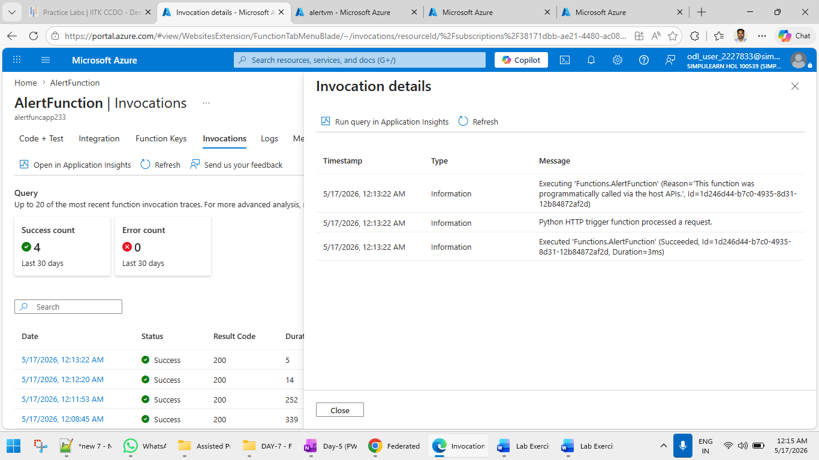
curl https://<FUNCTION_APP>.azurewebsites.net/api/AlertFunction

Example:
curl https://alertfuncapp233.azurewebsites.net/api/AlertFunction

Cleanup Resources
az group delete \
--name $RESOURCE_GROUP \
--yes \
--no-wait

Learning Outcomes
After completing this lab, you can:
- Create Azure Monitor alerts
- Configure Action Groups
- Trigger Azure Functions automatically
- Integrate monitoring with serverless automation
- Build event-driven cloud operations

Real-World Use Cases
Use Case | Example
Auto-remediation | Restart failed services
Notifications | Send alerts to teams
Security Response | Trigger incident workflows
Scaling Automation | Add resources automatically
Monitoring | Execute diagnostic scripts

